- Parallel Sensor Test
Project US00503S
Date: June 26th, 2010
Report by: Daniel Sponagle
Staff: Emily Data
Roger Sharpe
Scott Carlin
Jeremy Pierce
Shane Montechelle

QuickLay Version 4.00.04
Common folder V1.46
UTM Coordinates 696298E, 3646093N (WGS 84 / Zone 11N)
Coil Azimuth: 0° T
Declination 12E

Results:
Coil | Coil Type | Serial # | Test Passed | Test Failed | Task For
P50 | Phoenix | 2121 | TEST1-A |  | Site Hx, Hy
P50 | Phoenix | 2131 | TEST1-A |  | Site Hx, Hy
P50 | Phoenix | 2196 | TEST1-A |  | Site Hx, Hy
P50 | Phoenix | 2203 | TEST2-A |  | Site Hx, Hy
P50 | Phoenix | 2231 | TEST2-A |  | Site Hx, Hy
P50 | Phoenix | 2233 | TEST2-A |  | Site Hx, Hy
P50 | Phoenix | 2239 | TEST1-A |  | Site Hx, Hy
P50 | Phoenix | 2242 | TEST1-A |  | Site Hx, Hy
P50 | Phoenix | 2243 | TEST1-A |  | Site Hx, Hy
P50 | Phoenix | 2248 | TEST1-B |  | Site Hx, Hy
P50 | Phoenix | 2254 | TEST1-B |  | Site Hx, Hy
P50 | Phoenix | 2388 | TEST1-B |  | Site Hx, Hy
P50 | Phoenix | 2393 | TEST1-B |  | Site Hx, Hy
P50 | Phoenix | 2394 | TEST1-B |  | Remote Hx
P50 | Phoenix | 2395 | TEST1-B |  | Remote Hy
Coil | Coil Type | Serial # | Test Passed | Test Failed | Task For
P50 | Phoenix | 2396 | TEST1-B |  | Remote Spare
P50 | Phoenix | 2444 | TEST2-A |  | Site Hx, Hy
P50 | Phoenix | 2447 | TEST2-A |  | Site Hx, Hy
P50 | Phoenix | 2448 |  | TEST2-A | FAIL
P50 | Phoenix | 2451 | TEST4 |  | Spare
P50 | Phoenix | 2456 | TEST4 |  | Spare
P50 | Phoenix | 2461 | TEST4 |  | Spare
BF7 | EMI | 7001 | TEST2-B |  | Site Hz
BF7 | EMI | 7005 | TEST2-B |  | Site Hz
BF7 | EMI | 7008 | TEST2-B |  | Site Hz
BF7 | EMI | 9107 | TEST8 |  | Spare
BF4 | EMI | 9115 | TEST8 |  | Spare
BF4 | EMI | 9119 | TEST8 |  | Spare
BF4 | EMI | 9122 | TEST2-B |  | Site Hz
BF4 | EMI | 9622 | TEST2-C |  | Site Hz
BF4 | EMI | 9623 | TEST2-C |  | Site Hz
BF4 | EMI | 9624 | TEST2-C |  | Site Hz
BF4 | EMI | 9639 | TEST2-B |  | Site Hz

Notes:
P50-2448: This coil was flagged as bad and continued to track badly on this PST (see Test2-A). Unit will be returned to office for repairs.
P50-2461: Always shows as completely overscaled despite numerous tests (see Test 3-A). Coil will be retested. The following day, it was determined that the problem lied within the spider. One side has bad z-port.
BF4-9119: Always shows as completely overscaled despite numerous tests (see Test 3-B). Coil will be retested. The following day, it was determined that the problem lied within the spider. One side has bad z-port.
One spider has bad z-port. It has been flagged.
- Low Frequency Coils ... Test 1-A

Available Coils:
TS Strip | Manufacture | Serial # | Logger # | Notes
1 | Phoenix | P50-2121 | 9E8D
2 | Phoenix | P50-2131 | 9E8D
3 | Phoenix | P50-2196 | 9E8D
4 | Phoenix | P50-2239 | 9EBD
5 | Phoenix | P50-2242 | 9EBD
6 | Phoenix | P50-2243 | 9EBD

Processing Parameters:
Parameters | Values
PSD Method | Welch
Window | Hanning
Window Length | 4096
Segment Overlap | 50%

- Test Results: 1000sps
Event Test 1-A
Serial Events: 9E8D_20100626.1821_2
9EBD_20100626.1826
Sample Rate: 1000sps
TS Length: 3,120,000 samples (~52min)

Results:
All coils OK
Time Series
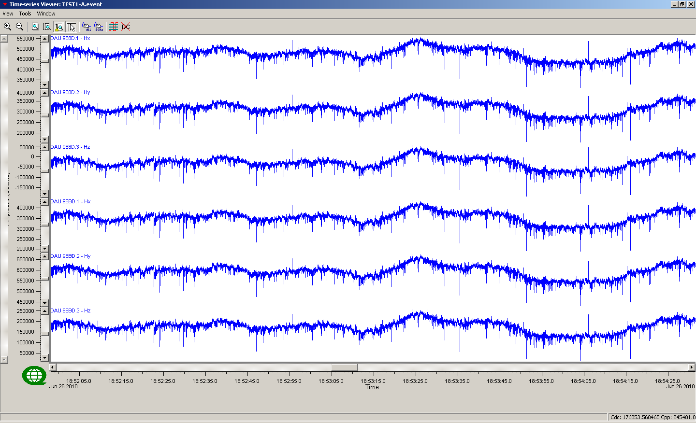
Time series @ 1000sps

Low Frequency Coil Results Coherency to P50-2121(Blue)
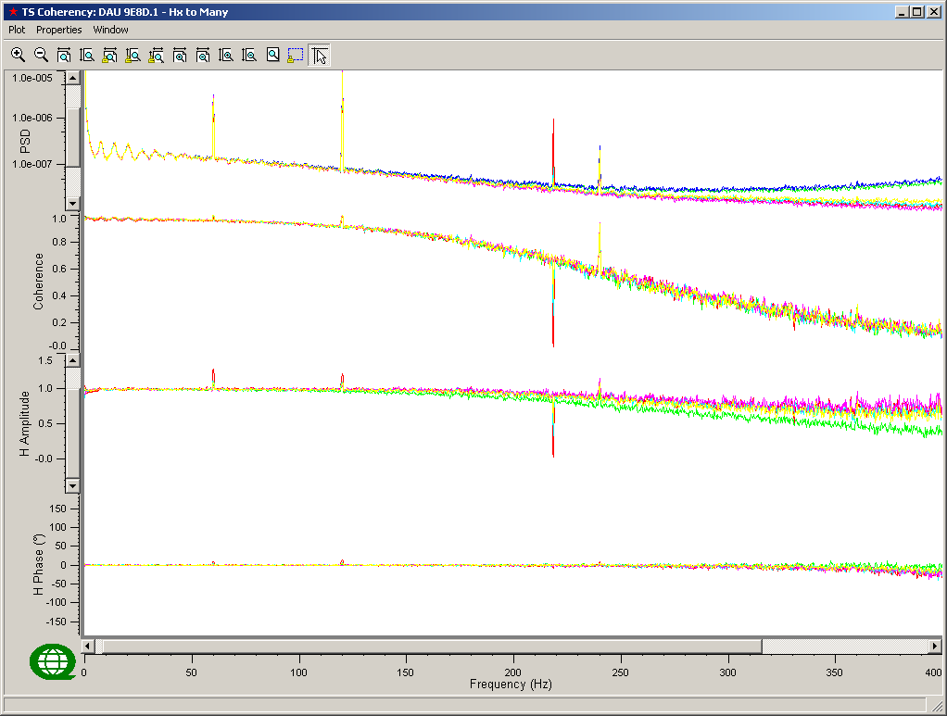
From top to bottom: PSD of channels and Coherency and Response Function (Amplitude and Phase) compared to Reference Channel – Linear frequency scale

Colour | Channel | Notes
Blue | P50-2121
Green | P50-2131
Red | P50-2196
Cyan | P50-2239
Magenta | P50-2242
Yellow | P50-2243
Black

Low Frequency Coil Results (continued) Coherency to P50-2121 (Blue)
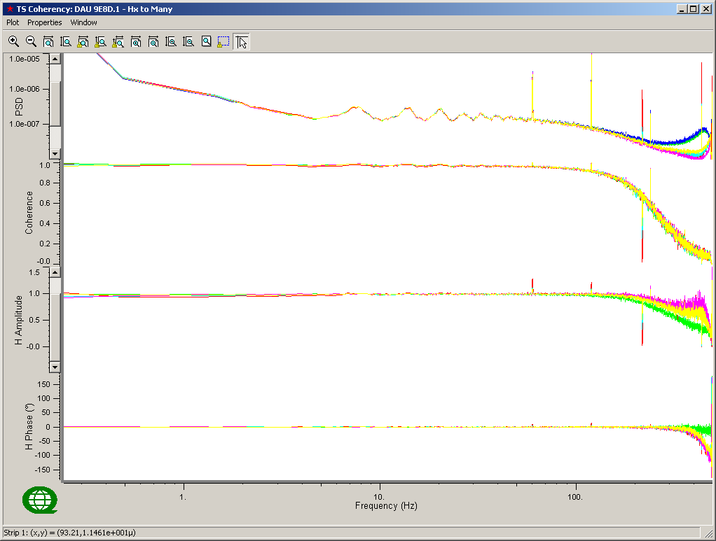
From top to bottom: PSD of channels and Coherency and Response Function (Amplitude and Phase) compared to Reference Channel – Logarithmic frequency scale
Colour | Channel | Notes
Blue | P50-2121
Green | P50-2131
Red | P50-2196
Cyan | P50-2239
Magenta | P50-2242
Yellow | P50-2243
Black

- Low Frequency Coils ... Test 1-b

Available Coils:
TS Strip | Manufacture | Serial # | Logger # | Notes
1 | Phoenix | P50-2248 | 9EAC
2 | Phoenix | P50-2254 | 9EAB
3 | Phoenix | P50-2388 | 9EAB
4 | Phoenix | P50-2393 | 9EAB
5 | Phoenix | P50-2394 | 9EBA
6 | Phoenix | P50-2395 | 9EBA
7 | Phoenix | P50-2296 | 9EBA

Processing Parameters:
Parameters | Values
PSD Method | Welch
Window | Hanning
Window Length | 4096
Segment Overlap | 50%

- Test Results: 1000sps
Event Test 1-B
Serial Events: 9EAC_20100626.1825
9EBA_20100626.1829
9EAB_20100626.1828
Sample Rate: 1000sps
TS Length: 2,400,000 samples (~40min)

Results:
All coils OK
Time Series
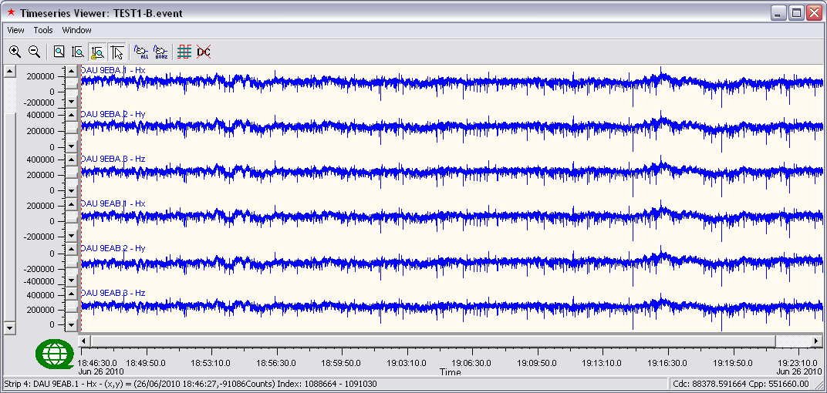
Time series @ 1000sps

Low Frequency Coil Results Coherency to P50-2395(Yellow)
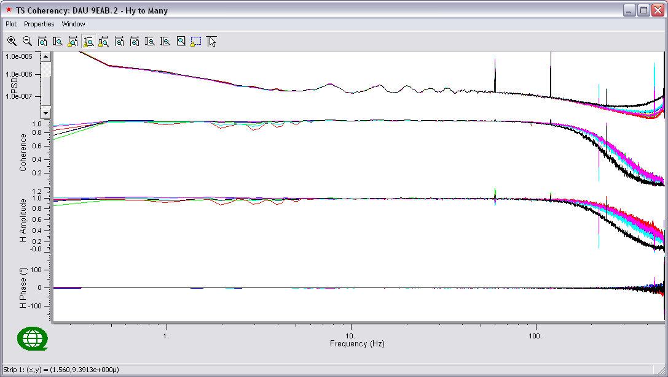
From top to bottom: PSD of channels and Coherency and Response Function (Amplitude and Phase) compared to Reference Channel – Linear frequency scale

Colour | Channel | Notes
Blue | P50-2248
Green | P50-2254
Red | P50-2388
Cyan | P50-2393
Magenta | P50-2394
Yellow | P50-2395
Black | P50-2296 | Lower PSD, coherency and amplitude above 150Hz

Low Frequency Coil Results (continued) Coherency to P50-2395 (Yellow)
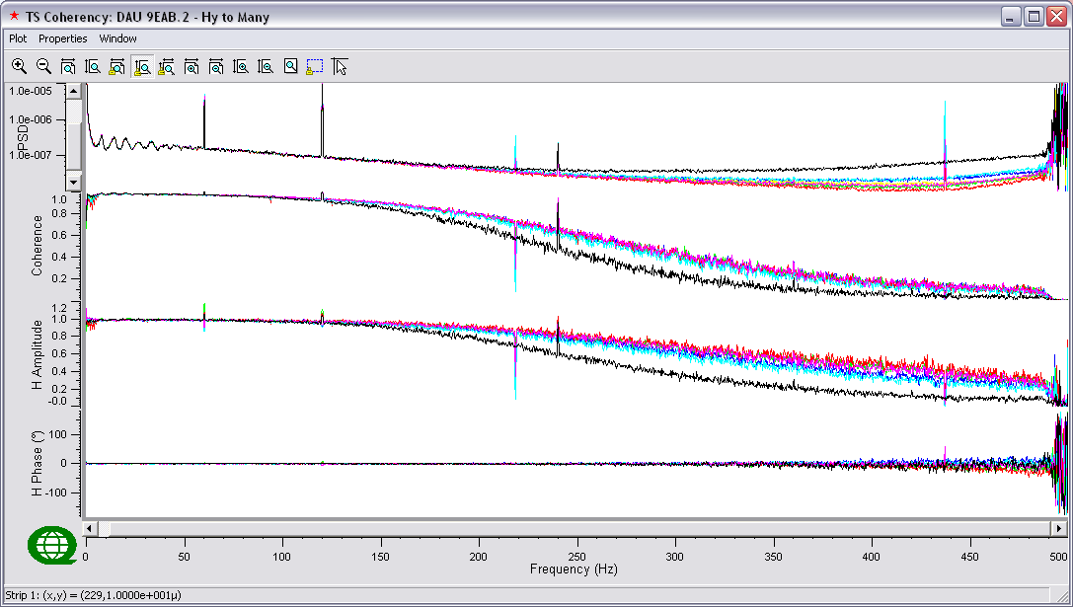
From top to bottom: PSD of channels and Coherency and Response Function (Amplitude and Phase) compared to Reference Channel – Logarithmic frequency scale
Colour | Channel | Notes
Blue | P50-2248
Green | P50-2254
Red | P50-2388
Cyan | P50-2393
Magenta | P50-2394
Yellow | P50-2395
Black | P50-2296 | Lower PSD, coherency and amplitude above 150Hz

- Low Frequency Coils ... Test 2-A

Available Coils:
TS Strip | Manufacture | Serial # | Logger # | Notes
1 | Phoenix | P50-2203 | 957C
2 | Phoenix | P50-2231 | 957C
3 | Phoenix | P50-2233 | 957C
4 | Phoenix | P50-2444 | 9579
5 | Phoenix | P50-2447 | 9579
6 | Phoenix | P50-2448 | 9579 | Also failed in previous PSTs. Was already flagged.

Processing Parameters:
Parameters | Values
PSD Method | Welch
Window | Hanning
Window Length | 4096
Segment Overlap | 50%

- Test Results: 1000sps
Event Test 2-A
Serial Events: 957C-2_20100626.2045
9579_20100626.2047
Sample Rate: 1000sps
TS Length: 1,620,000 samples (~27min)

Results:
P50-2448 – After failing in Test 1 group, coil cable was swapped for Test 2. Results stayed the same. Coil was flagged and operator mentioned that it failed previous PSTs.
Time Series
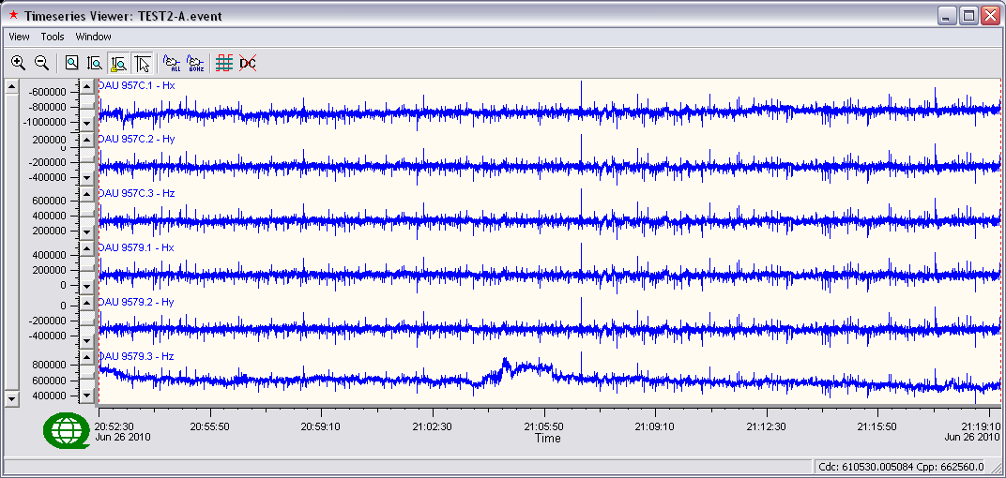
Time series @ 1000sps

Low Frequency Coil Results Coherency to P50-2231 (Green)
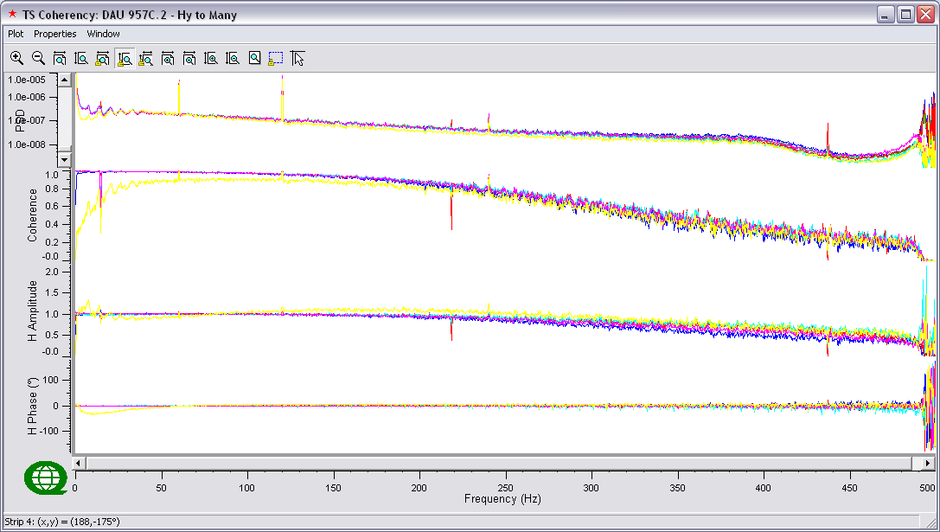
From top to bottom: PSD of channels and Coherency and Response Function (Amplitude and Phase) compared to Reference Channel – Linear frequency scale

Colour | Channel | Notes
Blue | P50-2203
Green | P50-2231
Red | P50-2233
Cyan | P50-2444
Magenta | P50-2447
Yellow | P50-2448 | Fails all parameters
Black

Low Frequency Coil Results (continued) Coherency to P50-2121 (Blue)
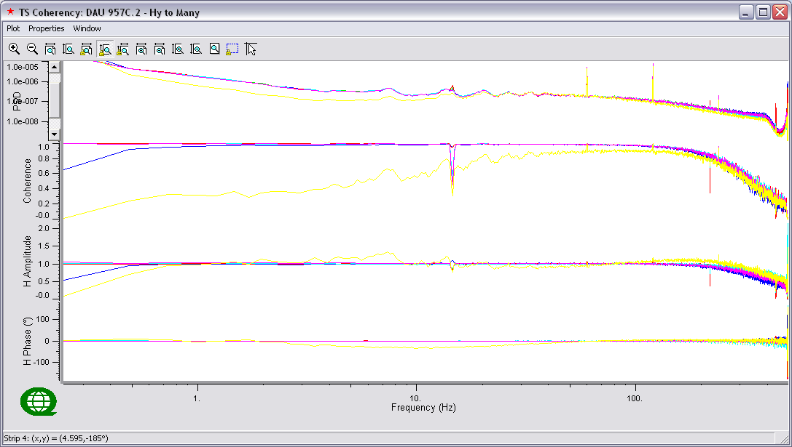
From top to bottom: PSD of channels and Coherency and Response Function (Amplitude and Phase) compared to Reference Channel – Logarithmic frequency scale
Colour | Channel | Notes
Blue | P50-2203
Green | P50-2231
Red | P50-2233
Cyan | P50-2444
Magenta | P50-2447
Yellow | P50-2448 | Fails all parameters
Black

- Low Frequency Coils ... Test 2-b

Available Coils:
TS Strip | Manufacture | Serial # | Logger # | Notes
1 | EMI | BF7-7001 | 9564
2 | EMI | BF7-7005 | 9564
3 | EMI | BF7-7008 | 9564
4 | EMI | BF4-9122 | 9E8D
5 | EMI | BF4-9836 | 9E8D
6

Processing Parameters:
Parameters | Values
PSD Method | Welch
Window | Hanning
Window Length | 4096
Segment Overlap | 50%

- Test Results: 1000sps
Event Test 2-B
Serial Events: 9564_20100626.2049
9E8D-2_20100626.2044
Sample Rate: 1000sps
TS Length: 1,620,000 samples (~27min)

Results:
Coherencies diverge above 250Hz for all coils. Likely all coils are okay.
Time Series
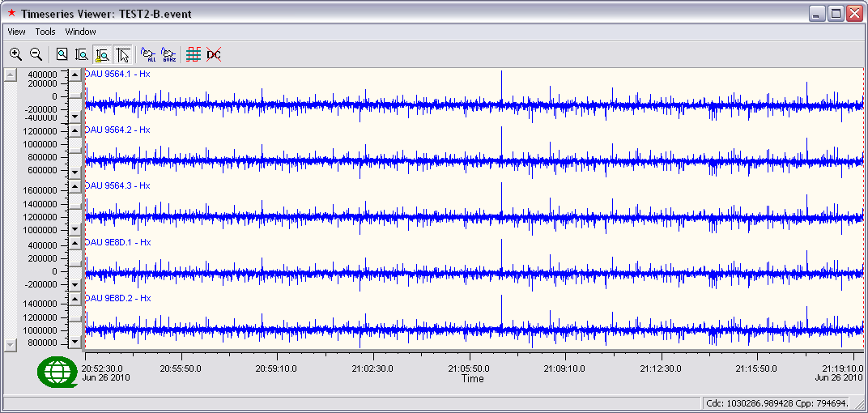
Time series @ 1000sps

Low Frequency Coil Results Coherency to BF7-7005(Green)
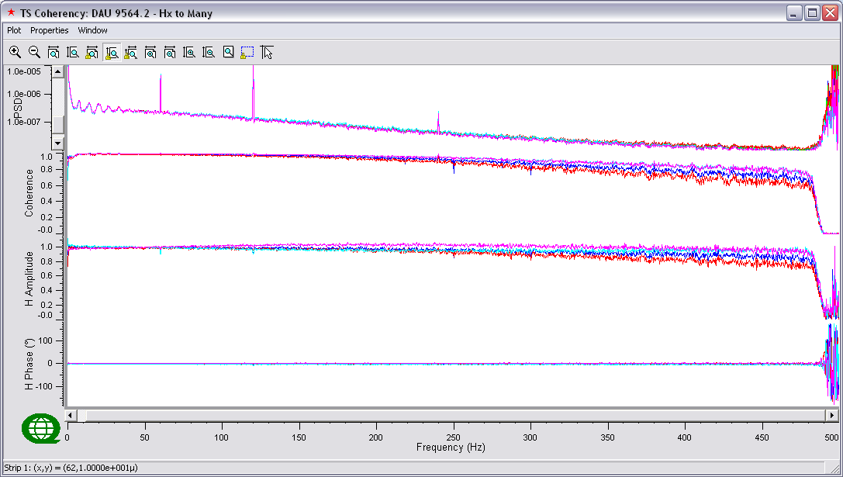
From top to bottom: PSD of channels and Coherency and Response Function (Amplitude and Phase) compared to Reference Channel – Linear frequency scale

Colour | Channel | Notes
Blue | BF7-7001
Green | BF7-7005
Red | BF7-7008
Cyan | BF4-9122
Magenta | BF4-9836
Yellow
Black

Low Frequency Coil Results (continued) Coherency to BF7-7005 (Green)
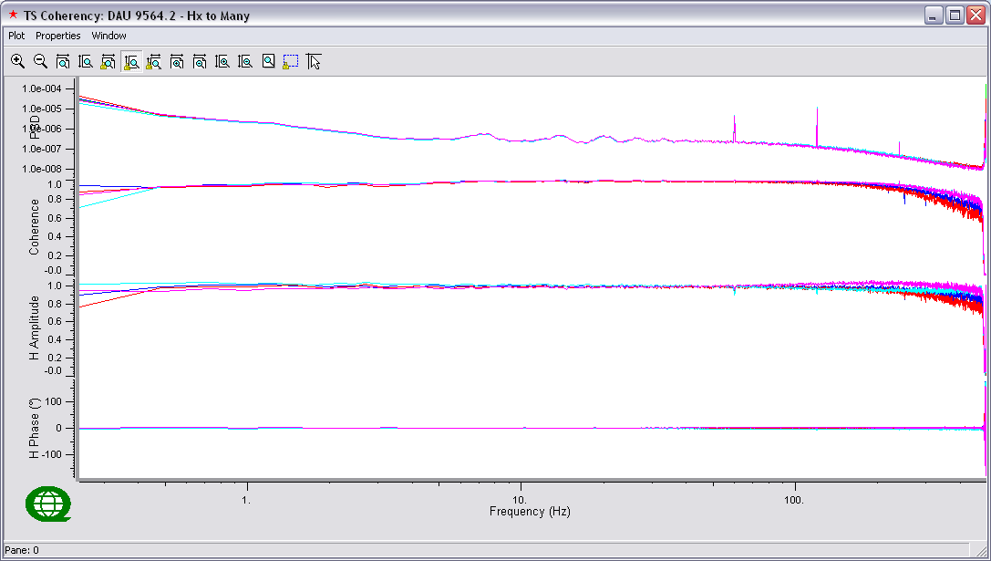
From top to bottom: PSD of channels and Coherency and Response Function (Amplitude and Phase) compared to Reference Channel – Logarithmic frequency scale
Colour | Channel | Notes
Blue | BF7-7001
Green | BF7-7005
Red | BF7-7008
Cyan | BF4-9122
Magenta | BF4-9836
Yellow
Black

- Low Frequency Coils ... Test 2-C

Available Coils:
TS Strip | Manufacture | Serial # | Logger # | Notes
1 | EMI | BF4-9122 | 9E8D
2 | EMI | BF4-9836 | 9E8D
3 | EMI | BF4-9622 | 9EBA
4 | EMI | BF4-9623 | 9EBA
5 | EMI | BF4-9624 | 9EBA
6

Processing Parameters:
Parameters | Values
PSD Method | Welch
Window | Hanning
Window Length | 4096
Segment Overlap | 50%

- Test Results: 1000sps
Event Test 2-C
Serial Events: 9E8D-2_20100626.2044
9EBA-2_20100626.2048
Sample Rate: 1000sps
TS Length: 1,560,000 samples (~26min)

Results:
All coils OK
Time Series
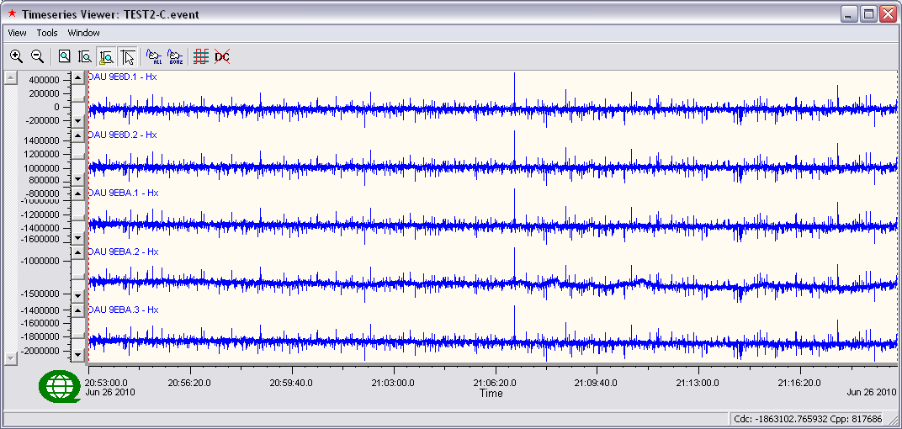
Time series @ 1000sps

Low Frequency Coil Results Coherency to BF4-9622(Red)
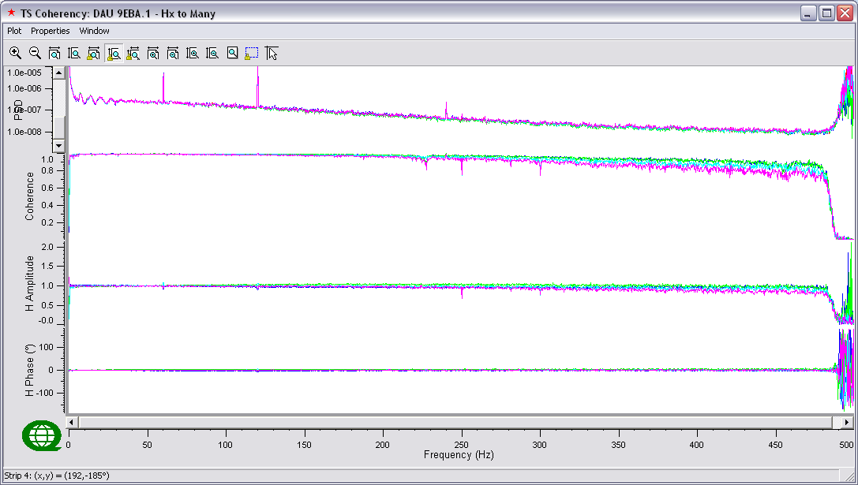
From top to bottom: PSD of channels and Coherency and Response Function (Amplitude and Phase) compared to Reference Channel – Linear frequency scale

Colour | Channel | Notes
Blue | BF4-9122
Green | BF4-9836
Red | BF4-9622
Cyan | BF4-9623
Magenta | BF4-9624 | Slightly lower coherencies above 250Hz
Yellow
Black

Low Frequency Coil Results (continued) Coherency to BF4-9622(Red)
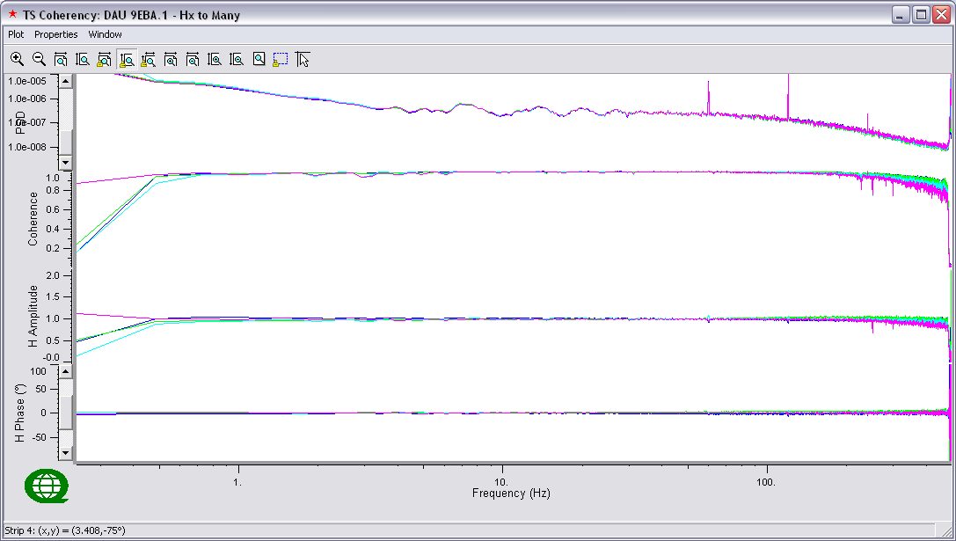
From top to bottom: PSD of channels and Coherency and Response Function (Amplitude and Phase) compared to Reference Channel – Logarithmic frequency scale
Colour | Channel | Notes
Blue | BF4-9122
Green | BF4-9836
Red | BF4-9622
Cyan | BF4-9623
Magenta | BF4-9624
Yellow
Black

- Low Frequency Coils ... Test 3-A

Available Coils:
TS Strip | Manufacture | Serial # | Logger # | Notes
1 | Phoenix | P50-2451 | 9571
2 | Phoenix | P50-2456 | 9571
3 | Phoenix | P50-2461 | 9571 | Fails all parameters
4
5
6

Processing Parameters:
Parameters | Values
PSD Method | Welch
Window | Hanning
Window Length | 4096
Segment Overlap | 50%

- Test Results: 1000sps
Event Test 3-A
Serial Events: 9571-3_20100626.2319
Sample Rate: 1000sps
TS Length: 1,440,000 samples (~24min)

Results:
Coils tested 3 times. Logger switched from 9F07 to 9571 (with Test 2 group). Coil cable switched for this test. Results are consistent.
Time Series
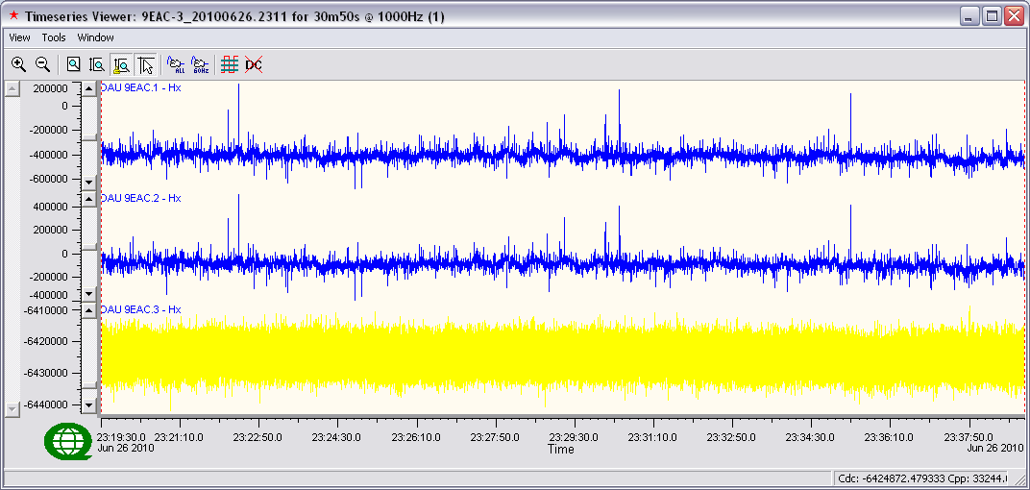
Time series @ 1000sps

Low Frequency Coil Results Coherency to P50-2451(Blue)
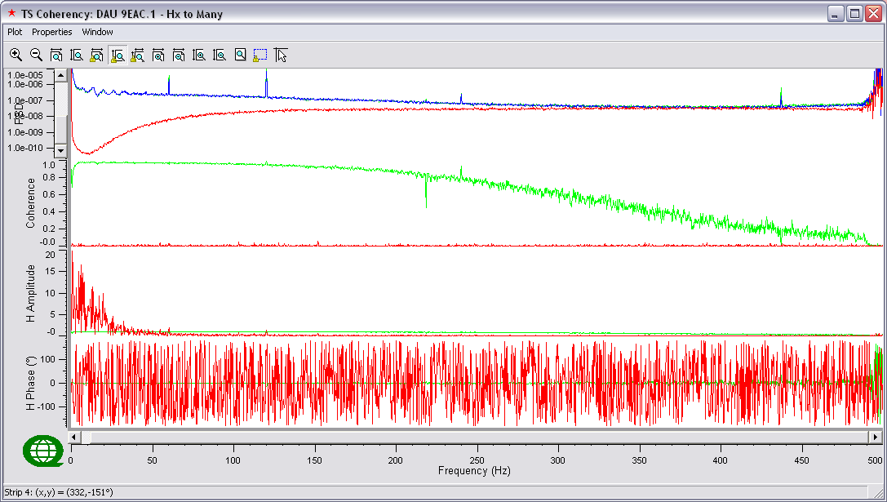
From top to bottom: PSD of channels and Coherency and Response Function (Amplitude and Phase) compared to Reference Channel – Linear frequency scale

Colour | Channel | Notes
Blue | P50-2451
Green | P50-2456 | Slightly lower coherencies below 1Hz
Red | P50-2461 | Fails all parameters
Cyan
Magenta
Yellow
Black

Low Frequency Coil Results (continued) Coherency to P50-2451(Blue)
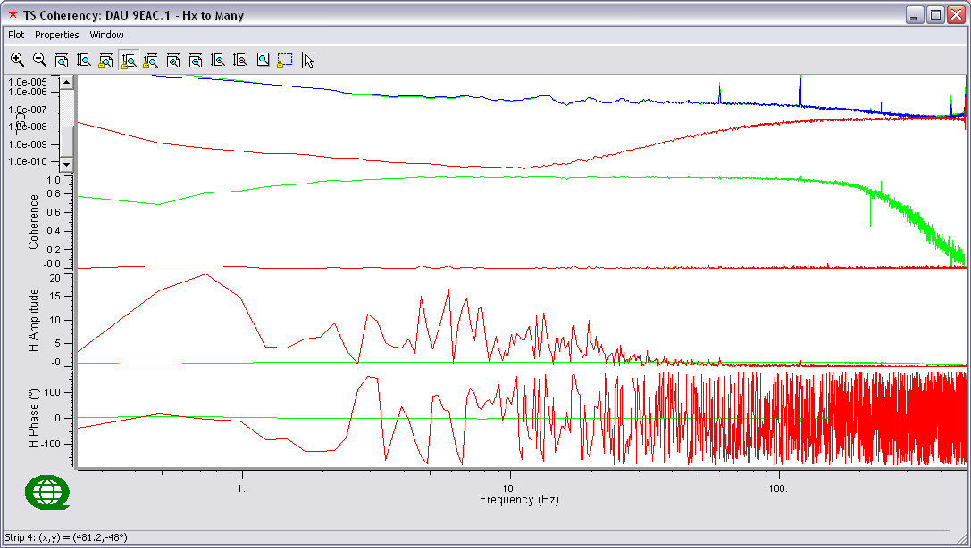
From top to bottom: PSD of channels and Coherency and Response Function (Amplitude and Phase) compared to Reference Channel – Logarithmic frequency scale
Colour | Channel | Notes
Blue | P50-2451
Green | P50-2456 | Slightly lower coherencies below 1Hz
Red | P50-2461 | Fails all parameters
Cyan
Magenta
Yellow
Black

- Low Frequency Coils ... Test3-b

Available Coils:
TS Strip | Manufacture | Serial # | Logger # | Notes
1 | EMI | BF4-9107 | 9571
2 | EMI | BF4-9115 | 9571
3 | EMI | BF4-9119 | 9571 | Fails all parameters
4
5
6

Processing Parameters:
Parameters | Values
PSD Method | Welch
Window | Hanning
Window Length | 4096
Segment Overlap | 50%

- Test Results: 1000sps
Event Test 3-B
Serial Events: 9571-3_20100626.2319
Sample Rate: 1000sps
TS Length: 1,440,000 samples (~24min)

Results:
Coil 9119 was tested 3 times: Coil cable was checked and tightened (with Test 1 group). Coil cable was swapped (with Test 2 group).

Time Series
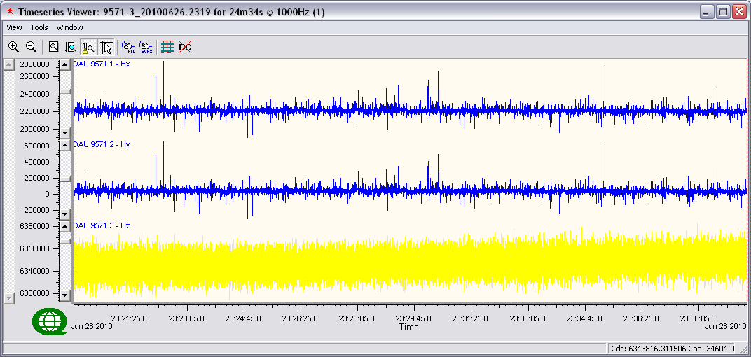
Time series @ 1000sps

Low Frequency Coil Results Coherency to BF4-9107(Blue)
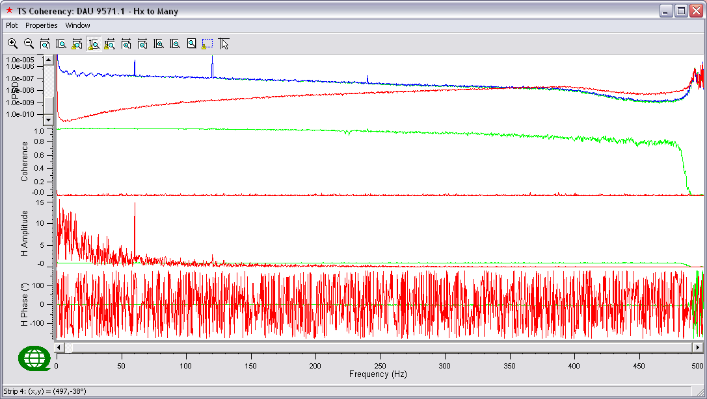
From top to bottom: PSD of channels and Coherency and Response Function (Amplitude and Phase) compared to Reference Channel – Linear frequency scale

Colour | Channel | Notes
Blue | BF4-9107
Green | BF4-9115
Red | BF4-9119 | Fails all parameters
Cyan
Magenta
Yellow
Black

Low Frequency Coil Results (continued) Coherency to BF4-9107(Blue)
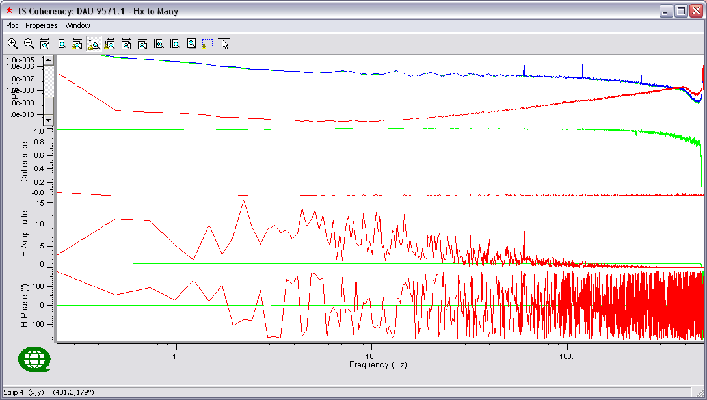
From top to bottom: PSD of channels and Coherency and Response Function (Amplitude and Phase) compared to Reference Channel – Logarithmic frequency scale
Colour | Channel | Notes
Blue | BF4-9107
Green | BF4-9115
Red | BF4-9119 | Fails all parameters
Cyan
Magenta
Yellow
Black

- Low Frequency Coils ... Test4 (DAY2)

Available Coils:
TS Strip | Manufacture | Serial # | Logger # | Notes
1 | Phoenix | P50-2451 | 9571
2 | Phoenix | P50-2456 | 9571
3 | Phoenix | P50-2461 | 9571
4
5
6

Processing Parameters:
Parameters | Values
PSD Method | Welch
Window | Hanning
Window Length | 4096
Segment Overlap | 50%

- Test Results: 1000sps
Event Test4
Serial Events: pst2_20100627.1623
Sample Rate: 1000sps
TS Length: 1,560,000 samples (~26min)

Results:
All coils OK
Time Series
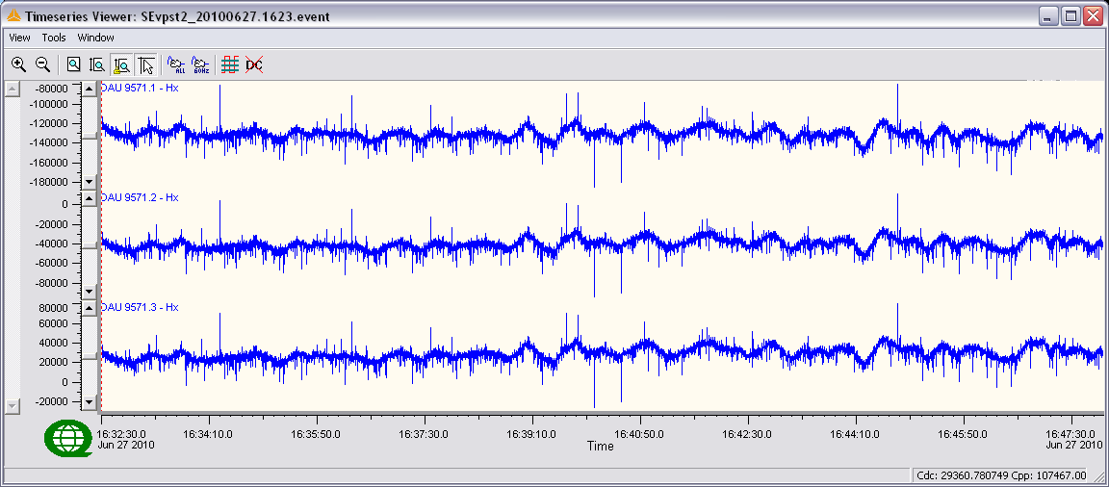
Time series @ 1000sps

Low Frequency Coil Results Coherency to P50-2451(Blue)
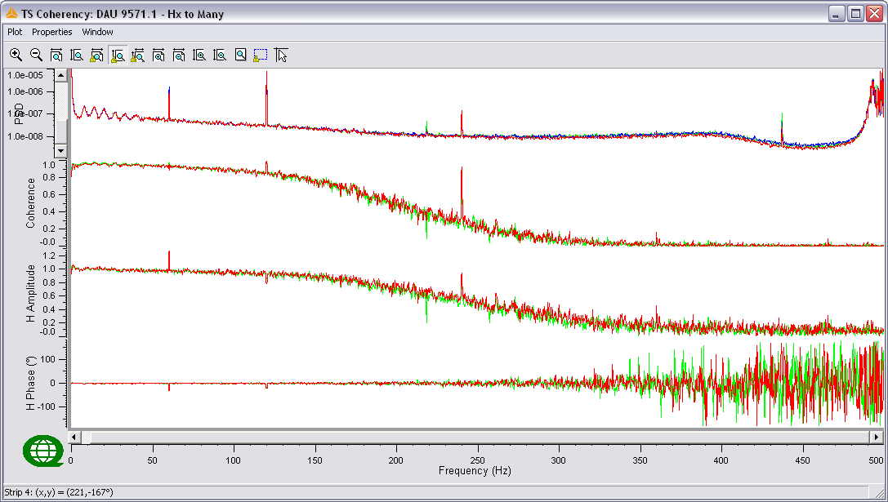
From top to bottom: PSD of channels and Coherency and Response Function (Amplitude and Phase) compared to Reference Channel – Linear frequency scale

Colour | Channel | Notes
Blue | P50-2451
Green | P50-2456
Red | P50-2461
Cyan
Magenta
Yellow
Black

Low Frequency Coil Results (continued) Coherency to P50-2451(Blue)
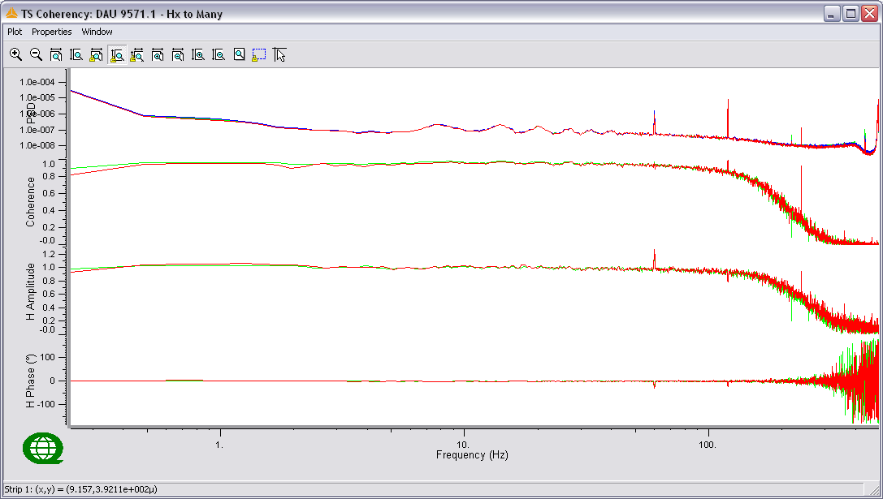
From top to bottom: PSD of channels and Coherency and Response Function (Amplitude and Phase) compared to Reference Channel – Logarithmic frequency scale
Colour | Channel | Notes
Blue | P50-2451
Green | P50-2456
Red | P50-2461
Cyan
Magenta
Yellow
Black

- Low Frequency Coils ... Test5
Available Coils:
TS Strip | Manufacture | Serial # | Logger # | Notes
1 | Phoenix | P50-2451 | 9571
2 | Phoenix | P50-2456 | 9571
3 | Phoenix | P50-2461 | 9571
4
5
6

- Test Results: 1000sps
Event Test5
Serial Events: 9571-5_20100627.1706
Sample Rate: 1000sps
TS Length: 780,000 samples (~13min)

Results:
Coils had previously passed test (Test4), after switching coils to opposite side of spider the z-coil did not track
Time Series
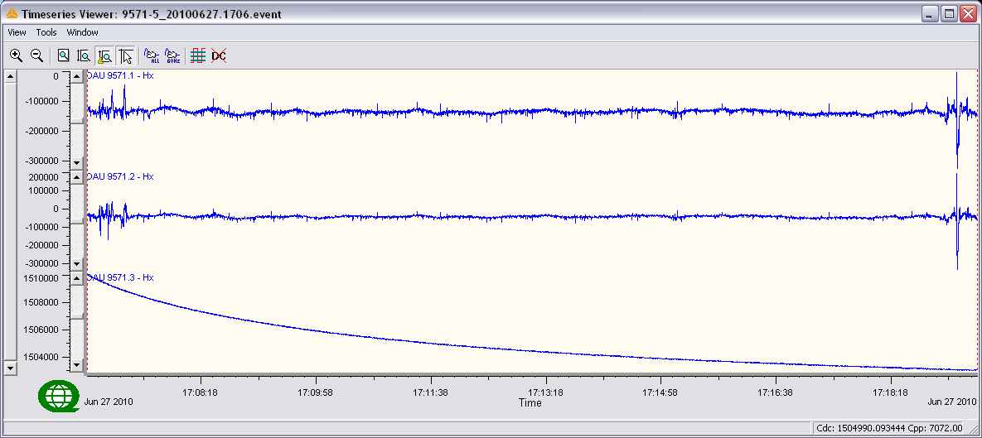
Time series @ 1000sps

- Low Frequency Coils ... Test6
Available Coils:
TS Strip | Manufacture | Serial # | Logger # | Notes
1 | Phoenix | P50-2461 | 9571
2 | Phoenix | P50-2456 | 9571
3 | Phoenix | P50-2451 | 9571
4
5
6

- Test Results: 1000sps
Event Test6
Serial Events: SEvpst2_20100627.1727
Sample Rate: 1000sps
TS Length: 600,000 samples (~10min)
Results:
After z-input failure in Test5 coils in x and z inputs were switched, z inputs continued to fail all parameters. Spider flagged as bad.
Time Series
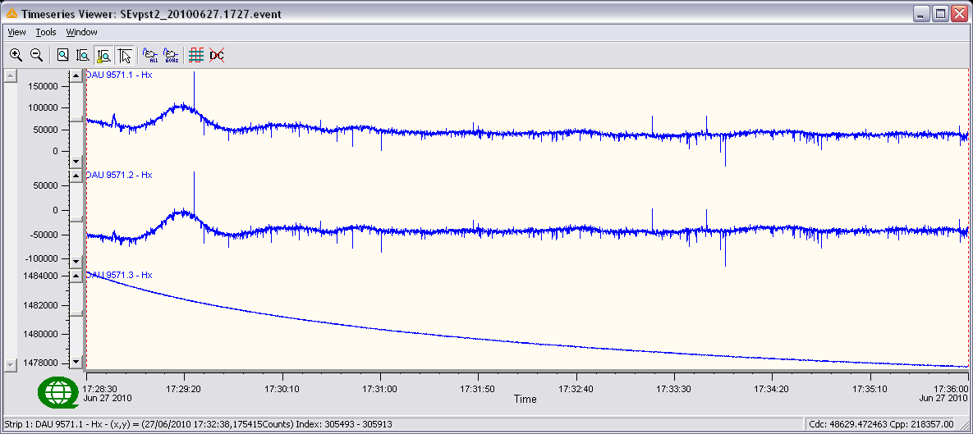
Time series @ 1000sps

- Low Frequency Coils ... Test7

Available Coils:
TS Strip | Manufacture | Serial # | Logger # | Notes
1 | Phoenix | P50-2451 | 9F07
2 | Phoenix | P50-2456 | 9F07
3 | Phoenix | P50-2461 | 9F07
4
5
6

Processing Parameters:
Parameters | Values
PSD Method | Welch
Window | Hanning
Window Length | 4096
Segment Overlap | 50%

- Test Results: 1000sps
Event Test7
Serial Events: 9FO7-7_20100627.1752
Sample Rate: 1000sps
TS Length: 480,000 samples (~8min)

Results:
After failing day 1 tests, 9F07 was retested using different spider, everything was OK.
Time Series
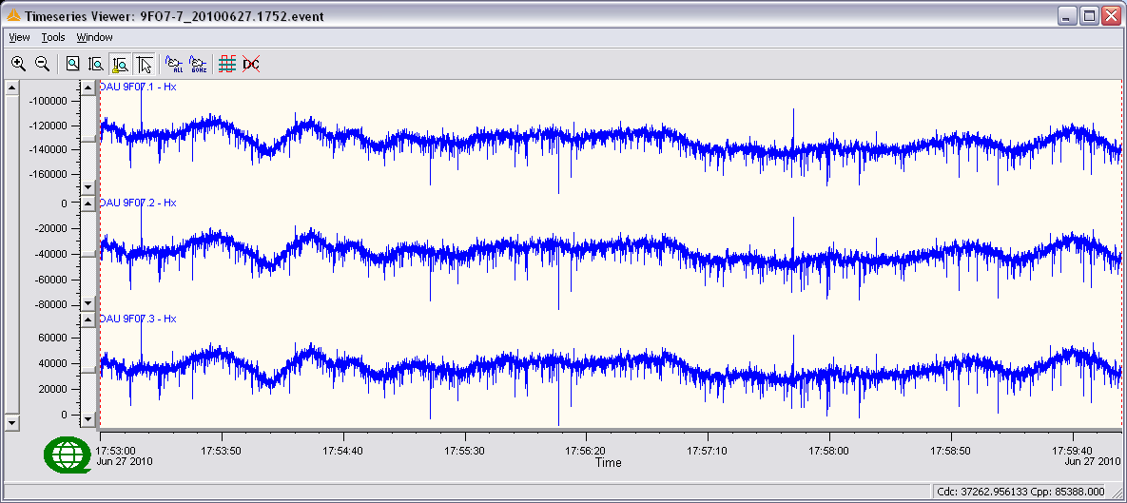
Time series @ 1000sps

Low Frequency Coil Results Coherency to P50-2461(Red)
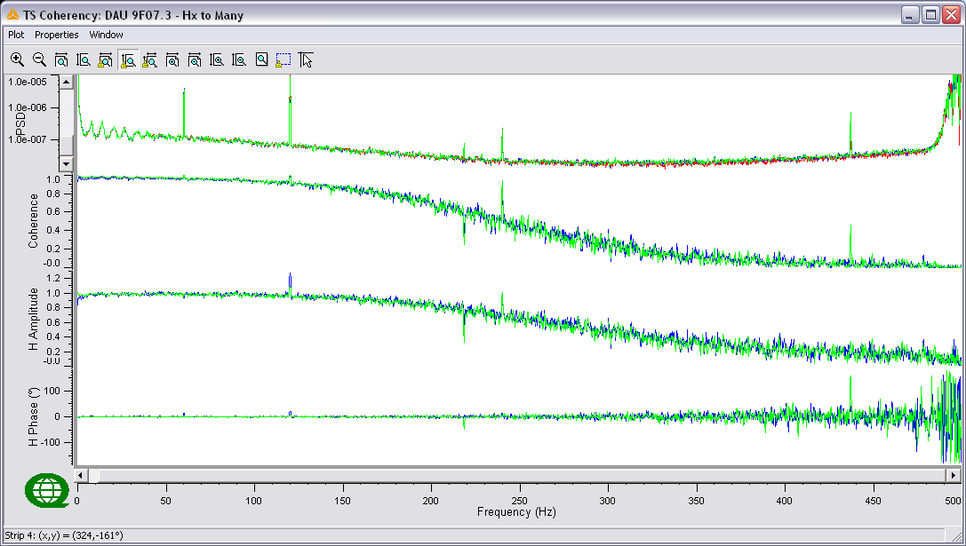
From top to bottom: PSD of channels and Coherency and Response Function (Amplitude and Phase) compared to Reference Channel – Linear frequency scale

Colour | Channel | Notes
Blue | P50-2451
Green | P50-2456
Red | P50-2461
Cyan
Magenta
Yellow
Black

Low Frequency Coil Results (continued) Coherency to P50-2461(Red)
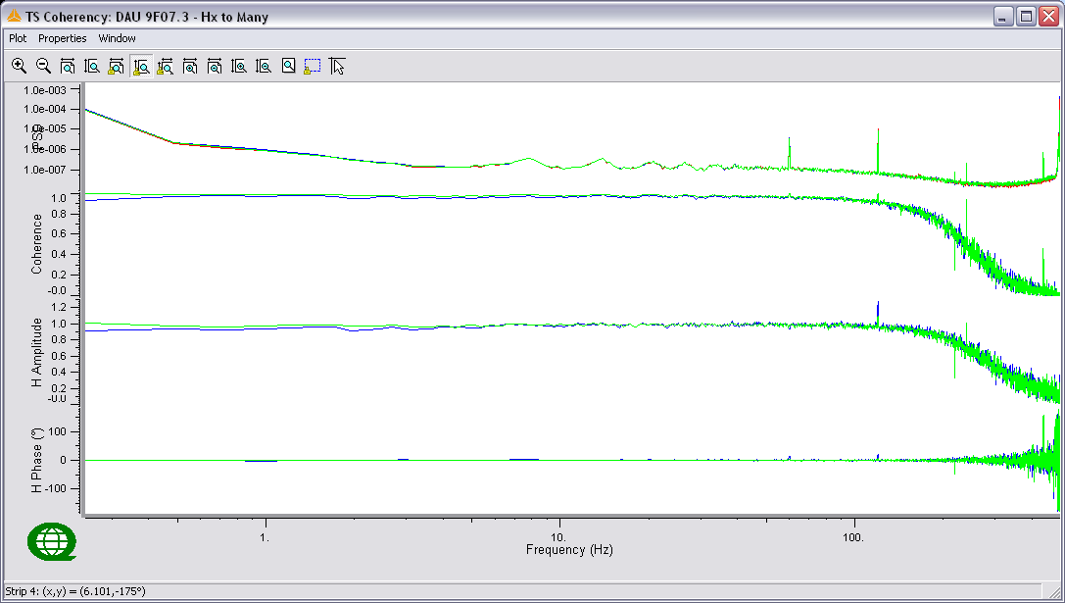
From top to bottom: PSD of channels and Coherency and Response Function (Amplitude and Phase) compared to Reference Channel – Logarithmic frequency scale
Colour | Channel | Notes
Blue | P50-2451
Green | P50-2456
Red | P50-2461
Cyan
Magenta
Yellow
Black

- Low Frequency Coils ... Test8

Available Coils:
TS Strip | Manufacture | Serial # | Logger # | Notes
1 | EMI | BF4-9107 | 9F07
2 | EMI | BF4-9115 | 9F07
3 | EMI | BF4-9119 | 9F07
4
5
6

Processing Parameters:
Parameters | Values
PSD Method | Welch
Window | Hanning
Window Length | 4096
Segment Overlap | 50%

- Test Results: 1000sps
Event Test8
Serial Events: 9FO7-8_20100627.1812
Sample Rate: 1000sps
TS Length: 960,000 samples (~16min)

Results:
All coils OK
Time Series
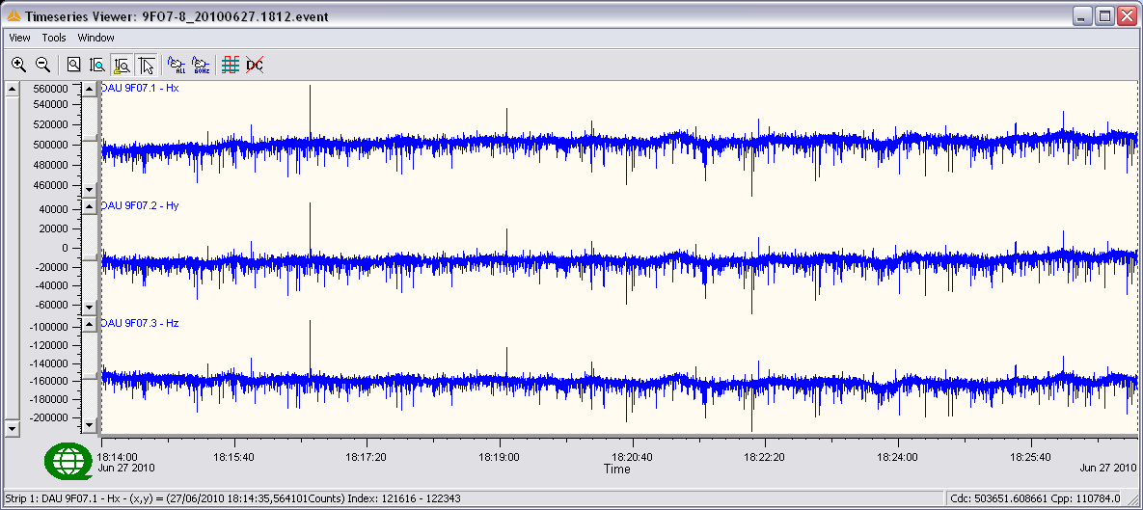
Time series @ 1000sps

Low Frequency Coil Results Coherency to BF4-9107(Blue)
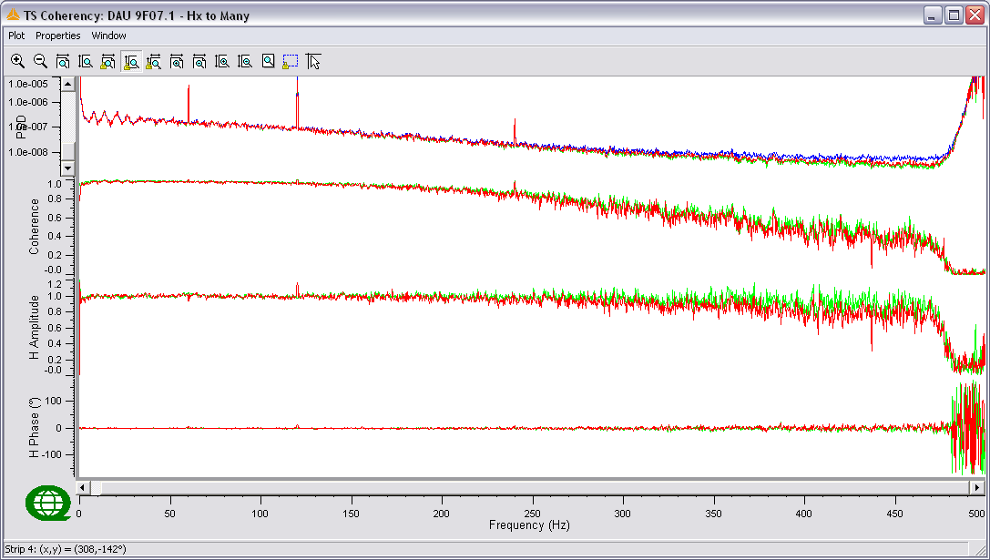
From top to bottom: PSD of channels and Coherency and Response Function (Amplitude and Phase) compared to Reference Channel – Linear frequency scale

Colour | Channel | Notes
Blue | BF4-9107
Green | BF4-9115
Red | BF4-9119
Cyan
Magenta
Yellow
Black

Low Frequency Coil Results (continued) Coherency to BF4-9107(Blue)
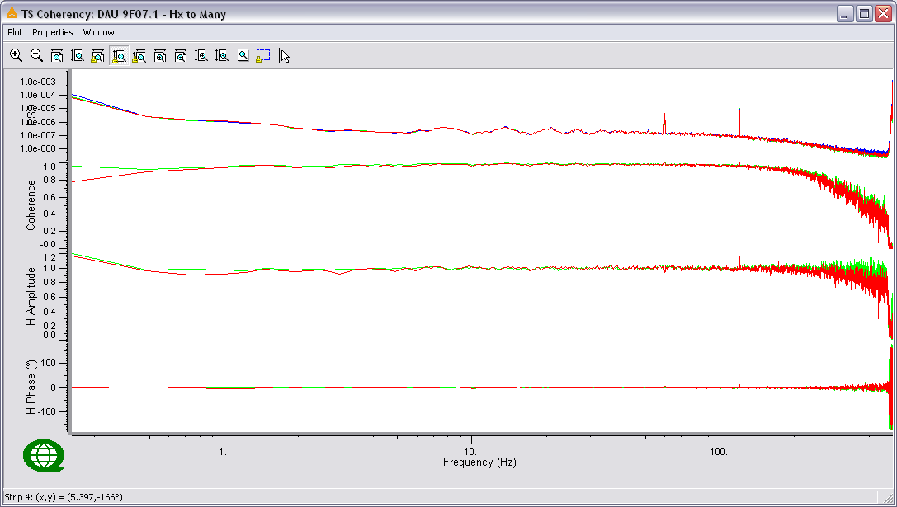
From top to bottom: PSD of channels and Coherency and Response Function (Amplitude and Phase) compared to Reference Channel – Logarithmic frequency scale
Colour | Channel | Notes
Blue | BF4-9107
Green | BF4-9115
Red | BF4-9119
Cyan
Magenta
Yellow
Black

